**Lassa Kaul**

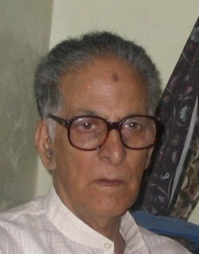

**About:** A resident of Be mina in Srinagar, Lassa Kaul was the director of Door darshan Centre. He was a calm and composed man. His behavior was such that he would have had hardly made any enemies ever. His cultured demeanor had won him maximum friends and well-wishers among the Muslims as well. But with rising voices of Muslim bigotry he was projected as the enemy of Islam, responsible for launching a cultural aggression on the Muslims through his programs on the Television center in Srinagar which he headed as a Director.

Lassa Kaul, an employee with the Ministry of Information and Broadcasting, who was gunned down by JKLF (Jammu Kashmir Liberation Front) separatists outside his house in February 1990.

**Murdered on:** 13th February 1990.

**Attack details:**  On 13th February 1990, 45-year old Kaul was gunned down by the terrorists as soon as he stepped out. *At about 7:15 PM ,45-year old Kaul, director with Doordarshan Kashmir, was visiting his ailing parents. As he stepped out of his vehicle, he was gunned down by terrorists.*

**Reason to him target:** The Director with Door darshan Kashmir was dead. Jammu Kashmir Liberation Front attackers, who were critical of news station’s pro-India programs had threatened Kaul a several times.

**Occupation:** Lassa Kaul, an employee with the Ministry of Information and Broadcasting,Doordarshan director.

**Belief:** He was rising voices of Muslim bigotry he was projected as the enemy of Islam, responsible for launching a cultural aggression on the Muslims through his programmes on the Television centre in Srinagar which he headed as a Director.

**Rumor of any involvement:** Rumors had it that some of his colleagues were involved in the murder. He probably never realized that his own men could backstab him or it would turn fatal to him. It is believed that the information of his whereabouts was passed on to the militants by his Muslim colleagues only. His brutal assassination shook not only his entire community but also the administration.

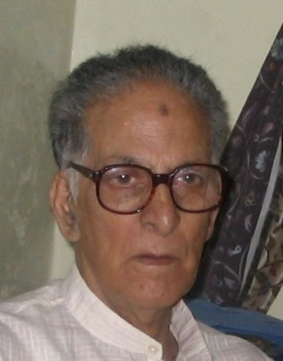**URL:** <https://www.opindia.com/2019/11/lassa-kaul-doordarshan-kashmir-exodus-1990/>

